Program 2

s=int(input("Enter Start year:"))

e=int(input("Enter end Year:"))

if(s<e):

print("Leap Year:",end=" ")

for i in range(s,e):

if(i%4==0 and i%100!=0):

print(i,end=" ")

Output :

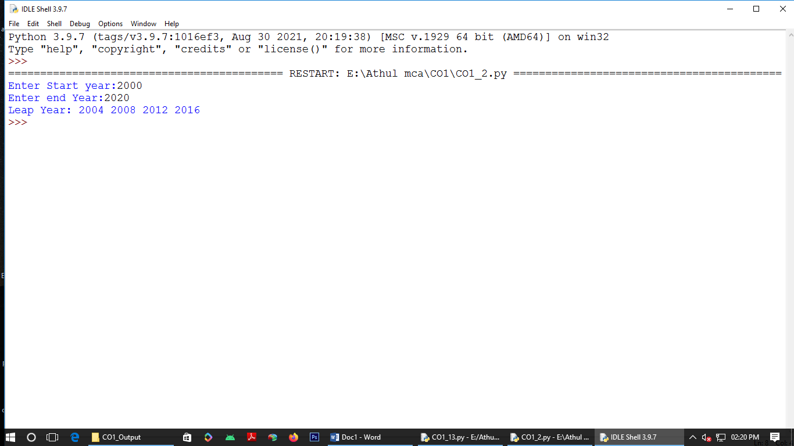

Program 3.1

list1=[10,20,-5,-10,34]

re=[num for num in list1 if num>=0]

print(re)

Output :

\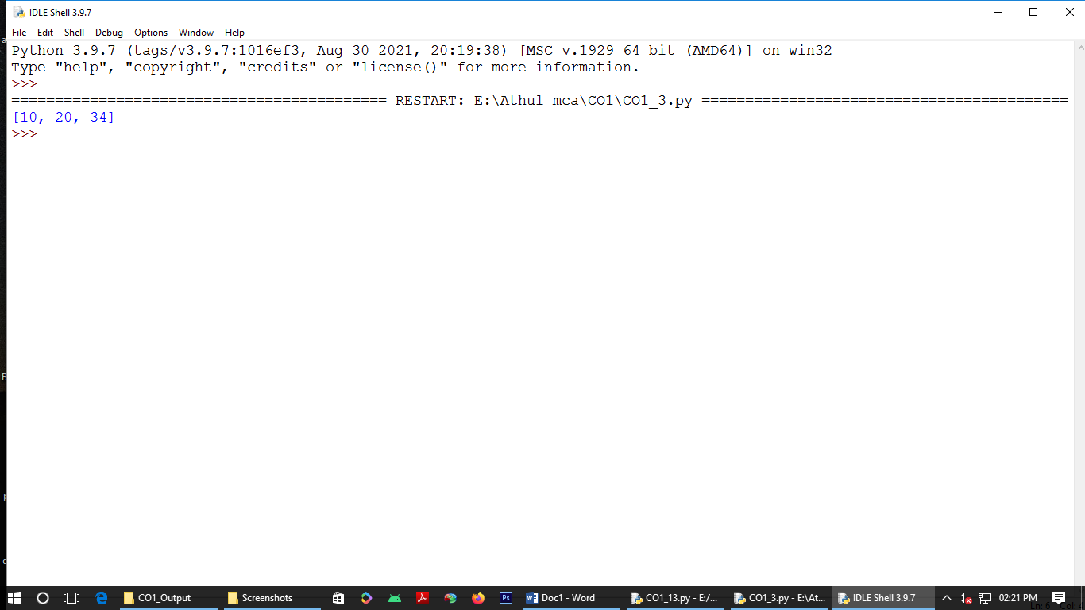

Program 3.2

n=int(input("Enter limit:"))

squarelist=[i**2 for i in range(1,n+1)]

print("Squares :",squarelist)

Output :

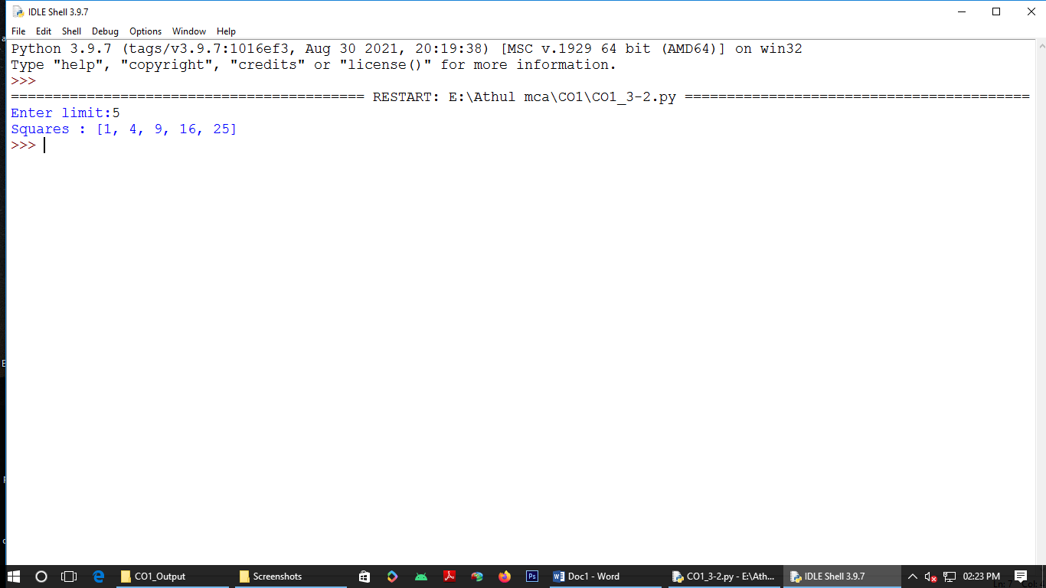

Program 3.3

word=str(input("Eter the word:"))

print("Original String:"+word)

print("Vowel:",end=" ")

for i in word:

if i in 'aeiouAEIOU':

print([i],end=" ")

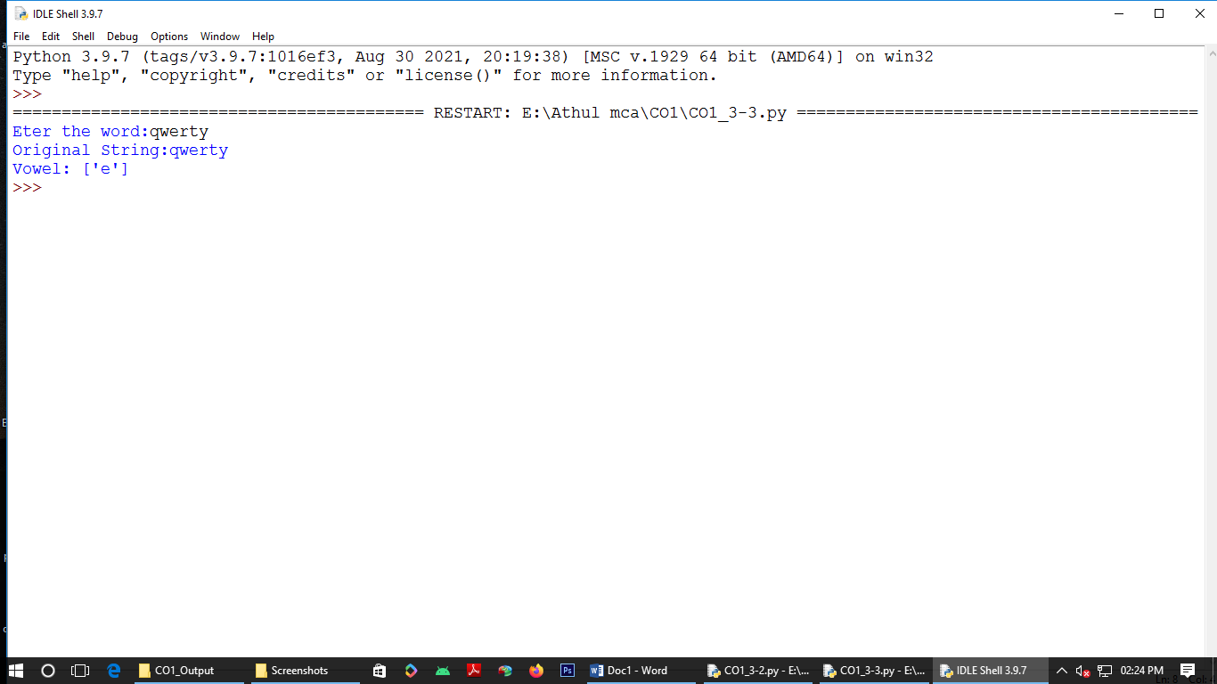

Program 3.4

w=input("Enter a word:")

print("Oridinal Val:")

for i in w:

print(i,end=" ")

print(ord(i),end=" ")

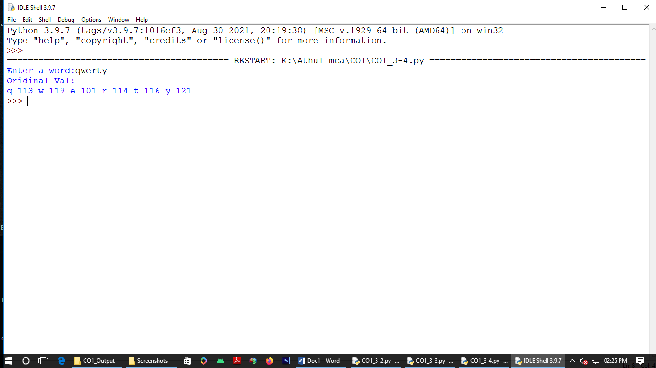

Program 4

str1=input("Enter a string")

wordlist=str1.split()

count=[]

for w in wordlist: count.append(wordlist.count(w))

print("count of the occurence"+ str(list(zip(wordlist,count))))

Output:

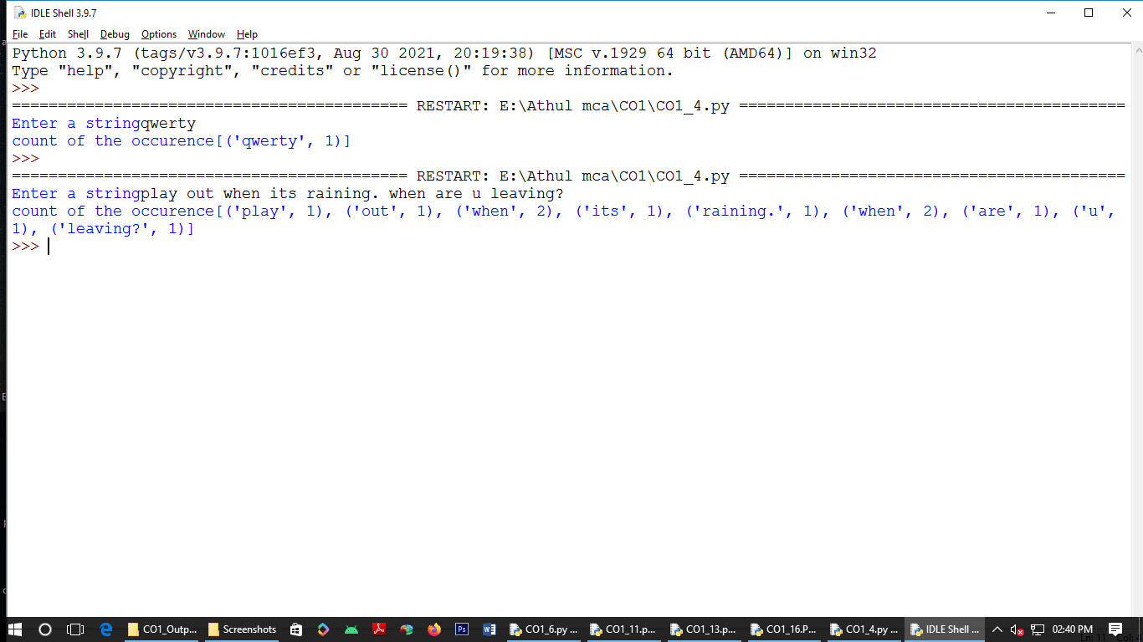

Program 5

n=[]

s=int(input("Enter the limit:"))

print("Enter {s} values")

for i in range(0,s):

n.append(int(input()))

print("\nThe list after assiging:\n")

for i in range(0,len(n)):

if(n[i]>=100):

print("over")

else:

print(n[i])

Output:

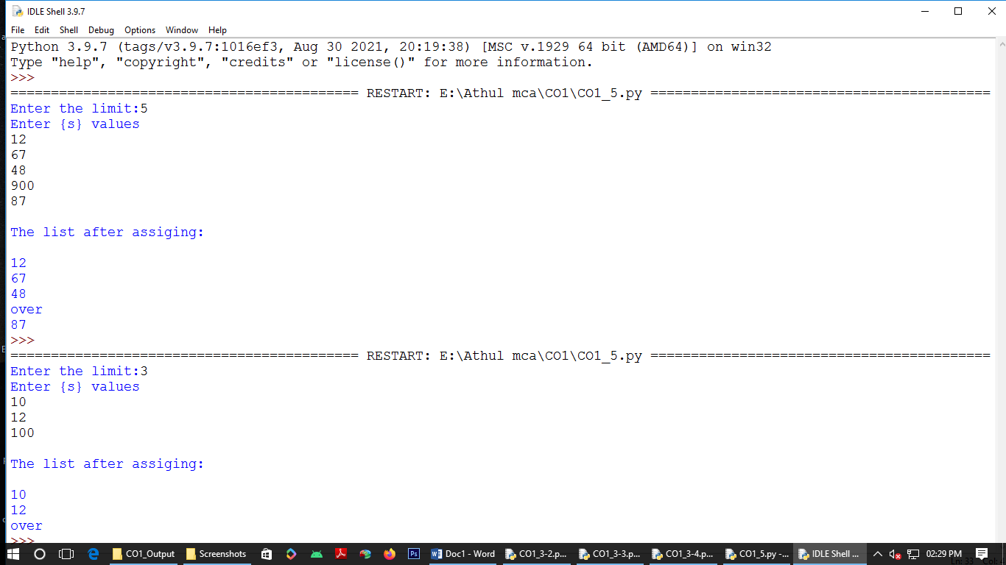

Program 6

a_list=["a","b","c"]

occ=a_list.count("a")

print("count of occurence of a:",occ)Output:

Output:

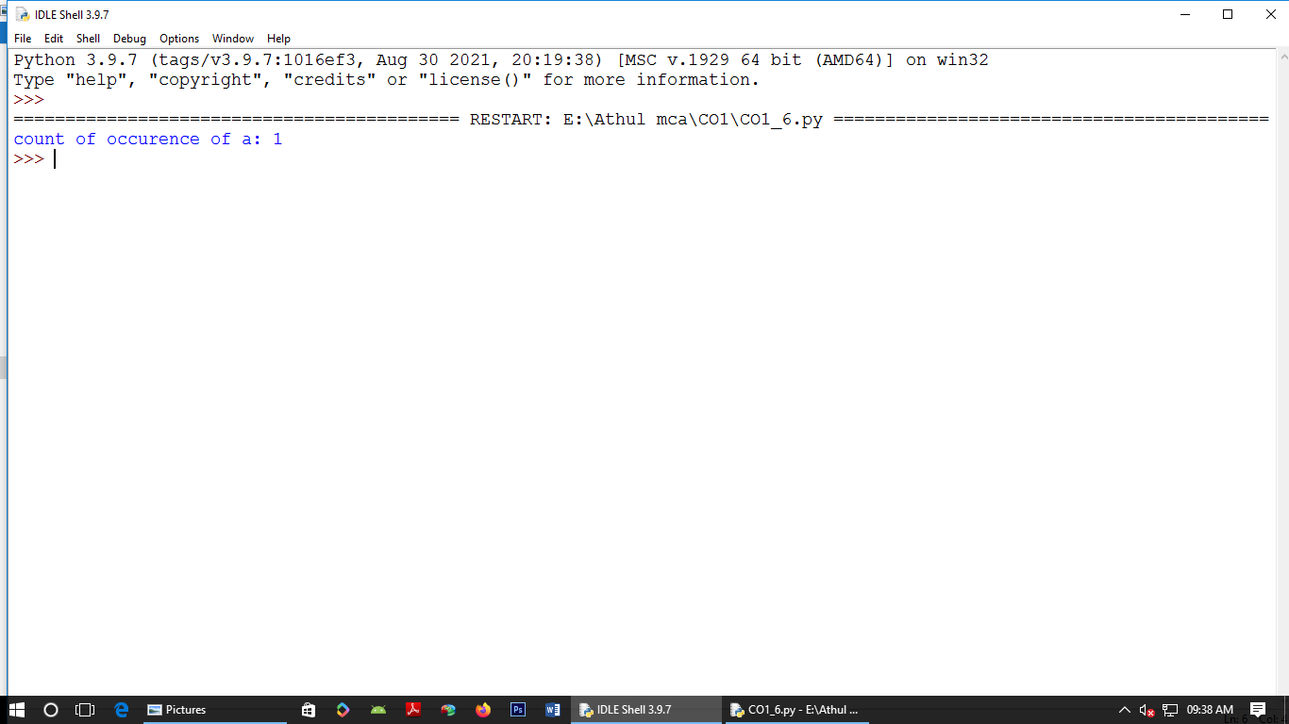

Program 7

lst=[1,3,5,7,9,11,34]

lst1=[5,13,45,7,20,65,1]

s=int(0)

c=int(0)

if len(lst)==len(lst1):

print("Lists are of same length")

else:

print("Lists have different length")

for i in range(0,len(lst) and len(lst1)):

s=s+lst[i]

c=c+lst1[i]

if(s==c):

print("equal sum")

else:

print("not same sum")

print("Elements that matched are:")

l=[]

for i in range(0,len(lst)):

for j in range(0,len(lst1)):

if lst[i]==lst1[j]:

l.append(lst[i] and lst1[j])

else:

continue

print(l)

Output:

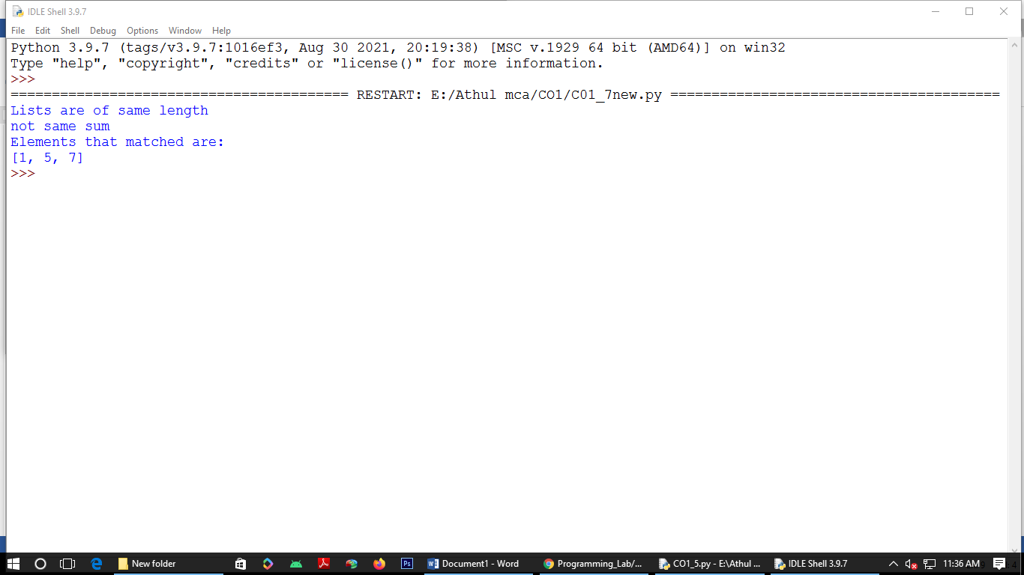

Program 8

str1="malayalam"

char=str1[0]

str1=str1.replace(char,'$')

str1=char+str1[1:]

print(str1)

Output:

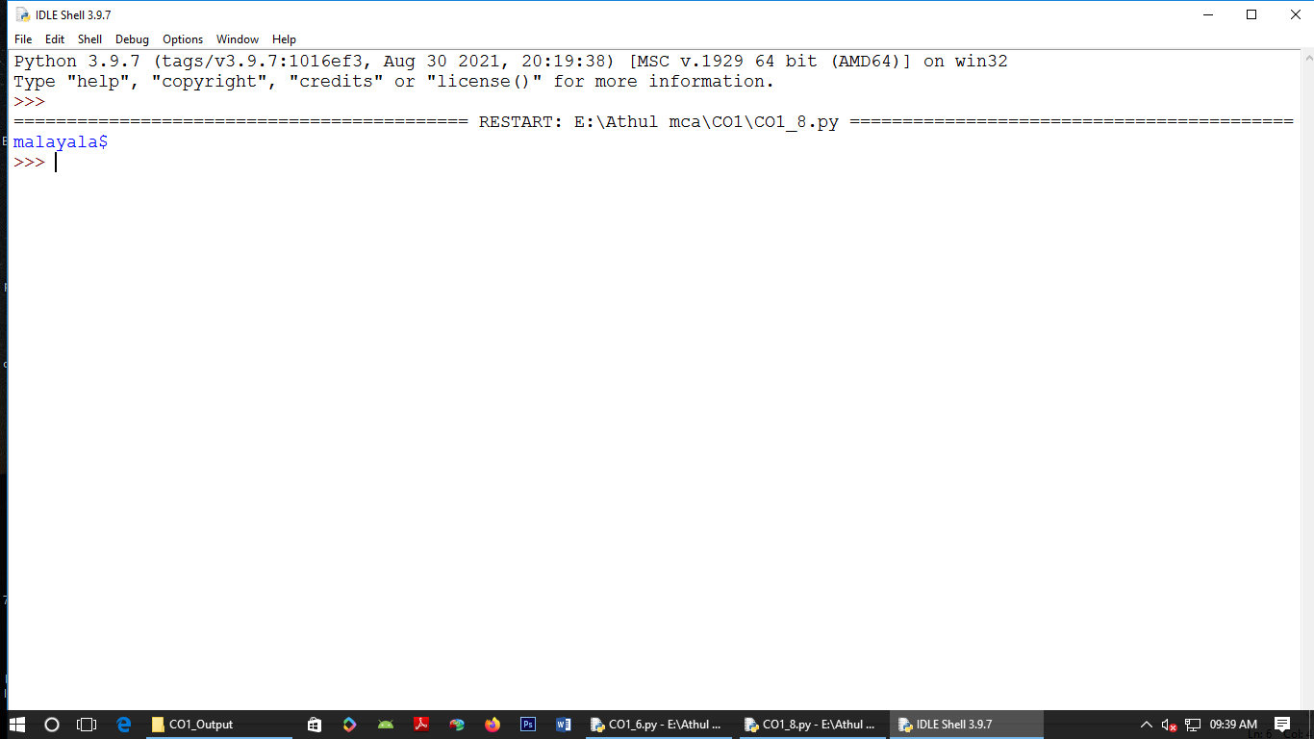

Program 9

str1="malayalam"

char=str1[0]

str1=str1.replace(char,'$')

str1=char+str1[1:]

print(str1)

Output:

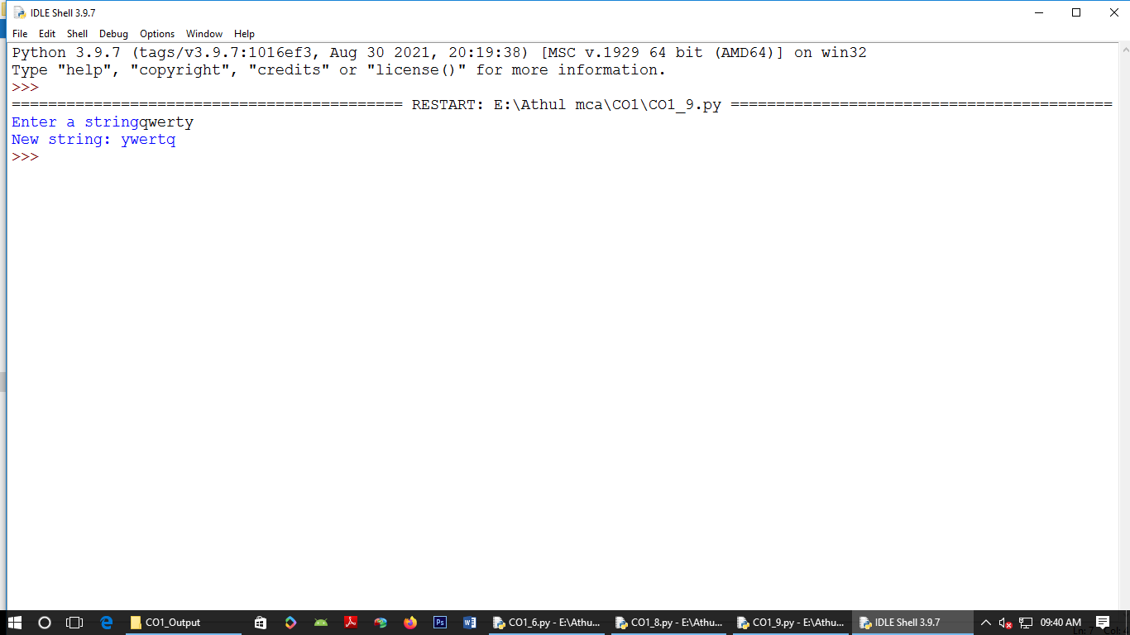

Program 10

pi=3.14

r=float(input("input the radius:"))

result=3.14*r*r

print("Area=",result)

Output:

: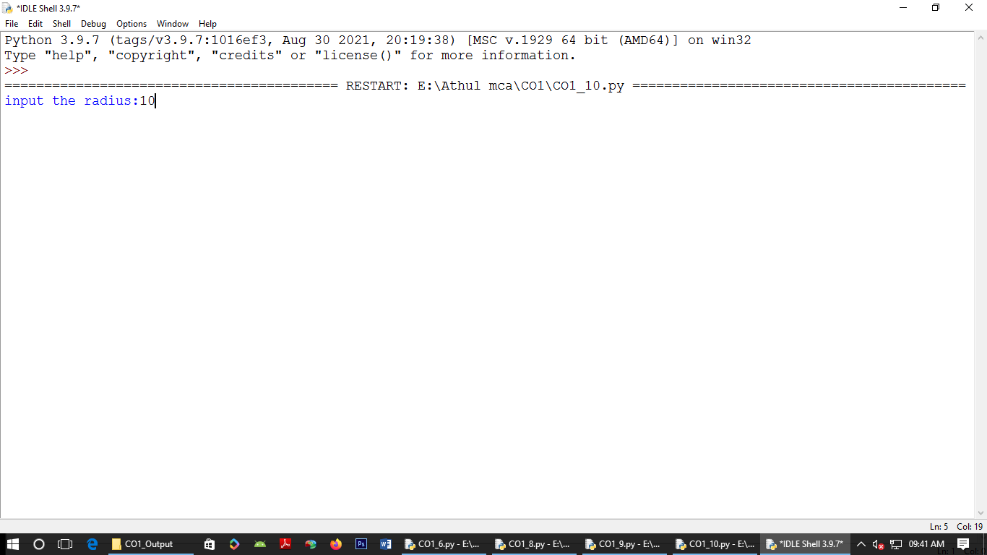

Program 11

x=int(input("Enter Num1:"))

y=int(input("Enter Num2:"))

z=int(input("Enter Num3:"))

if(x>y) and (x>z):

largest=x

elif(y>x) and (y>z):

largest=y

else:

largest=z

print("Largest=",largest)

Output:

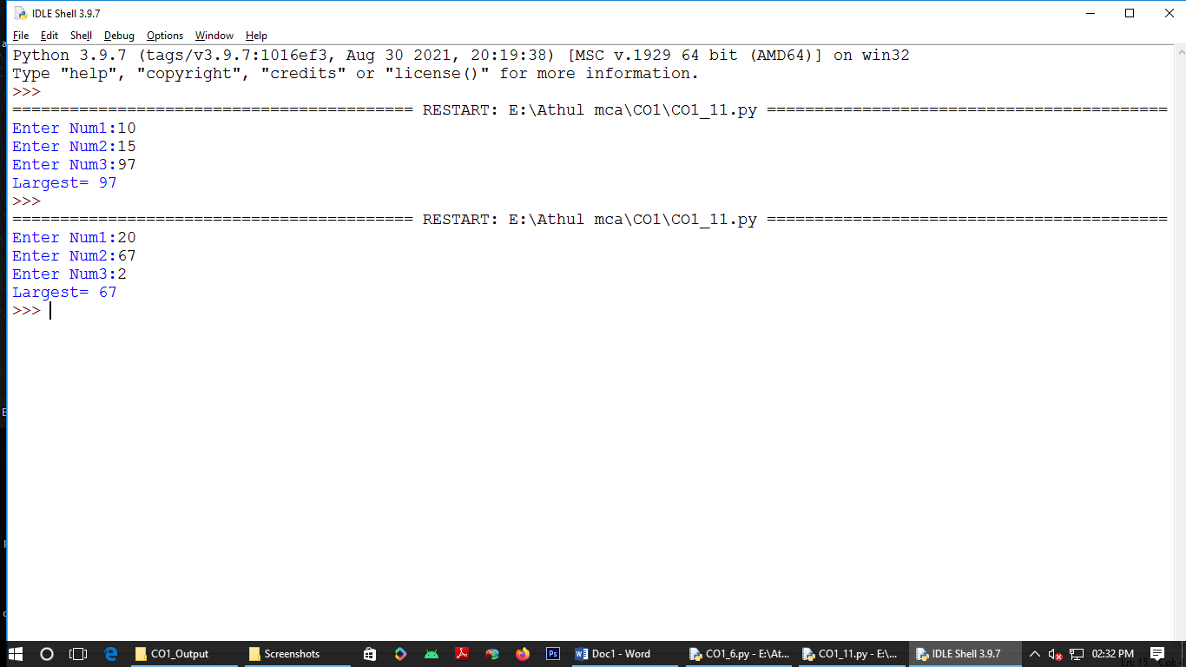

Program 12

file=input("Enter filename")

f=file.split(".")

print("Extension of the file is:"+f[-1])

Output:

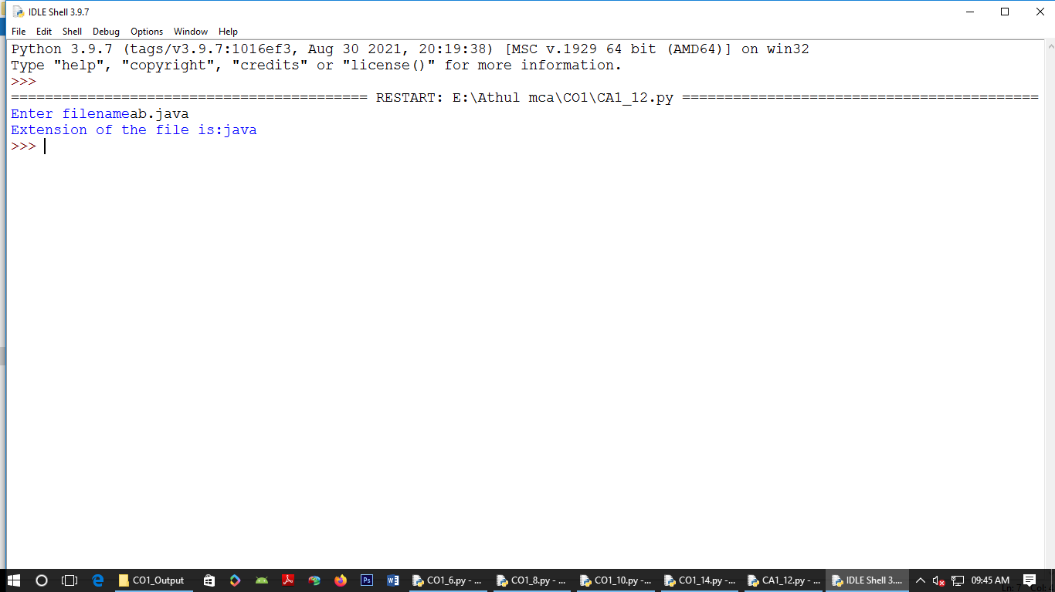

Program 13

a=[]

for i in range(3):

b=input("Enter the color:")

a.append(b)

print(a)

print("first: ",a[0])

print("Second: ",a[2])

Output:

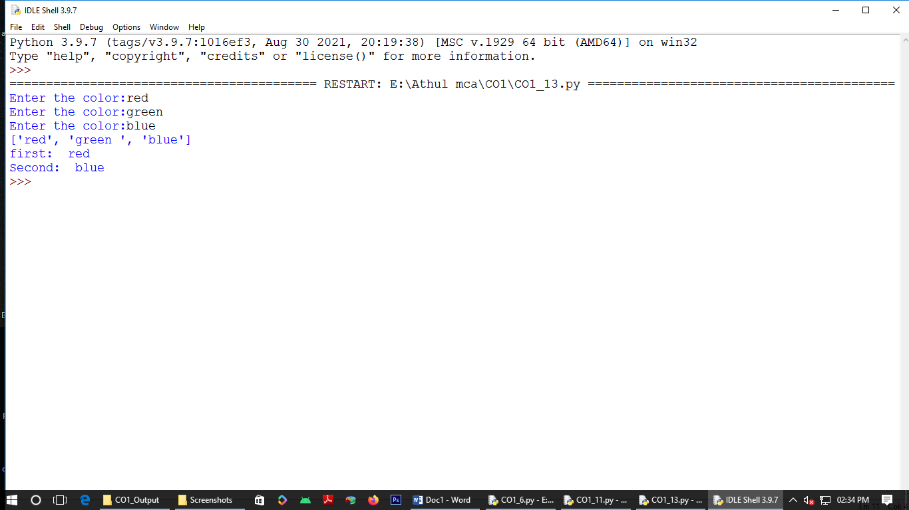

Program 14

n=int(input("Enter a number:"))

x=int("%s"%n)

y=int("%s%s"%(n,n))

z=int("%s%s%s"%(n,n,n))

print("n+nn+nnn:",x+y+z)

Output:

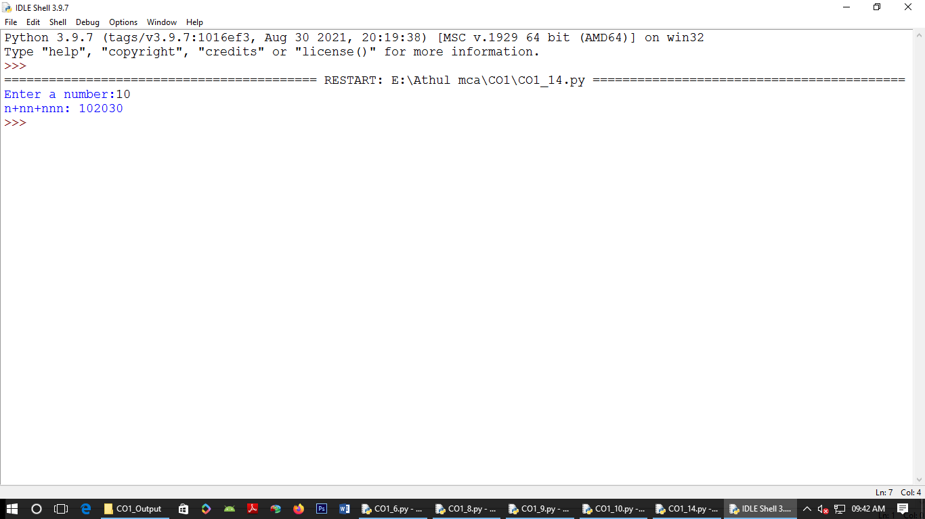

Program 15

color_list_1=set(["White","pink","Red","blue"])

color_list_2=set(["Red","Green","pink"])

print(color_list_1.difference(color_list_2))

Output:

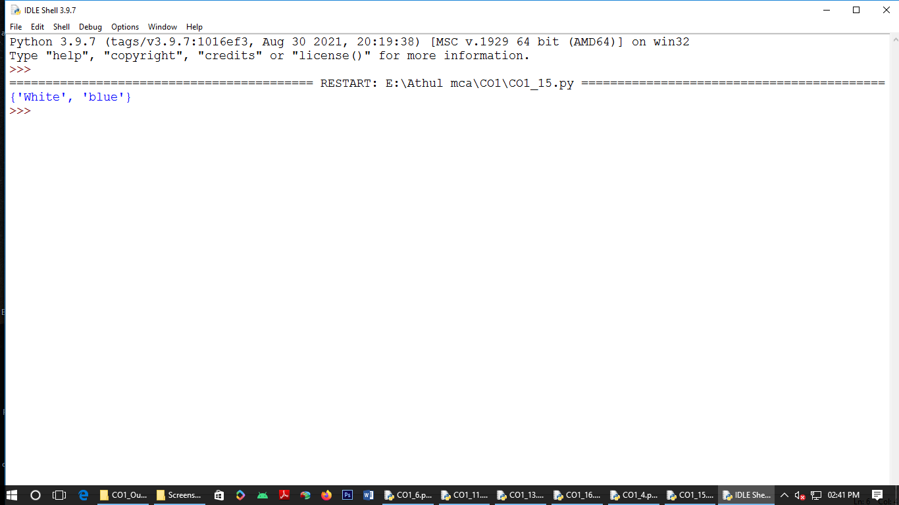

Program 16

a="python"

b="java"

p1=a[0]

p2=b[0]

c=b[0]+a[1:len(a)]+" "+a[0]+b[1:len(b)]

print(c)

Output:

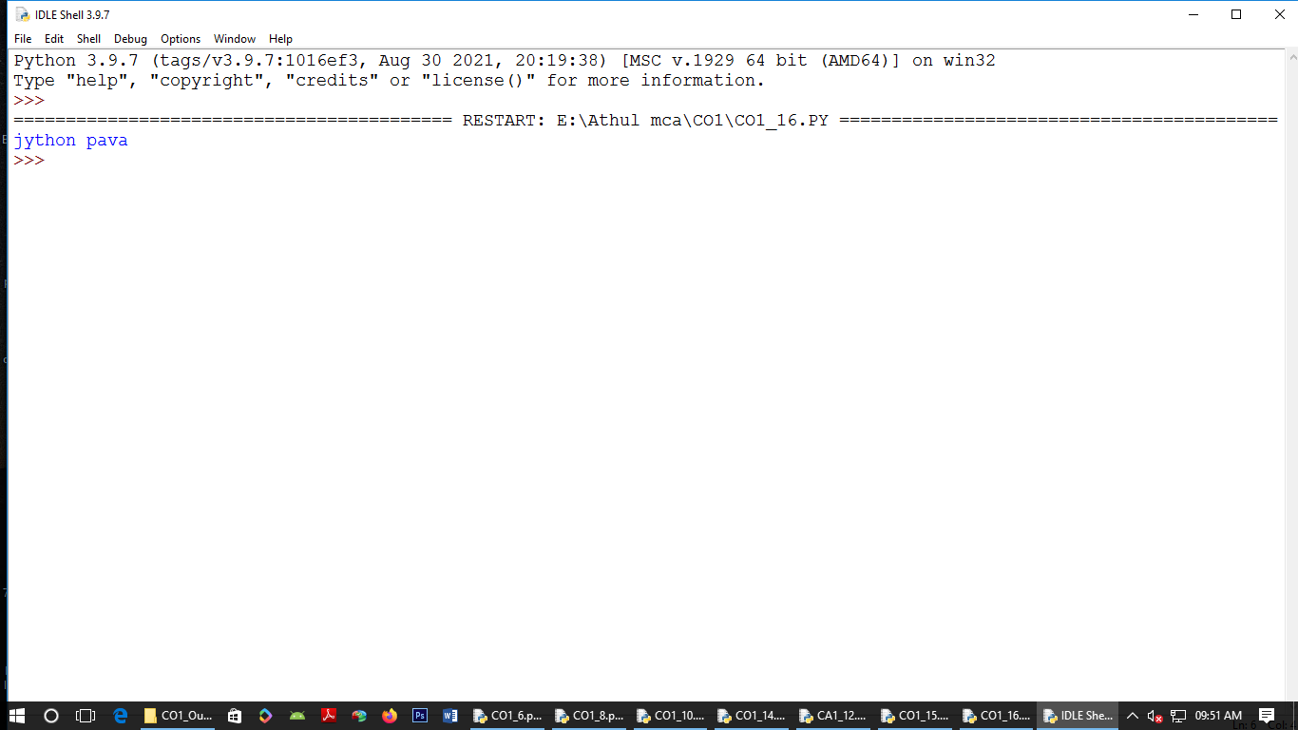

Program 19

x=int(input("Enter Num1:"))

y=int(input("Enter Num2:"))

i=1

while(i<=x and i<=y):

if(x%i==0 and y%i==0):

gcd=i

i=i+1

print("GCD:",gcd)

Output:

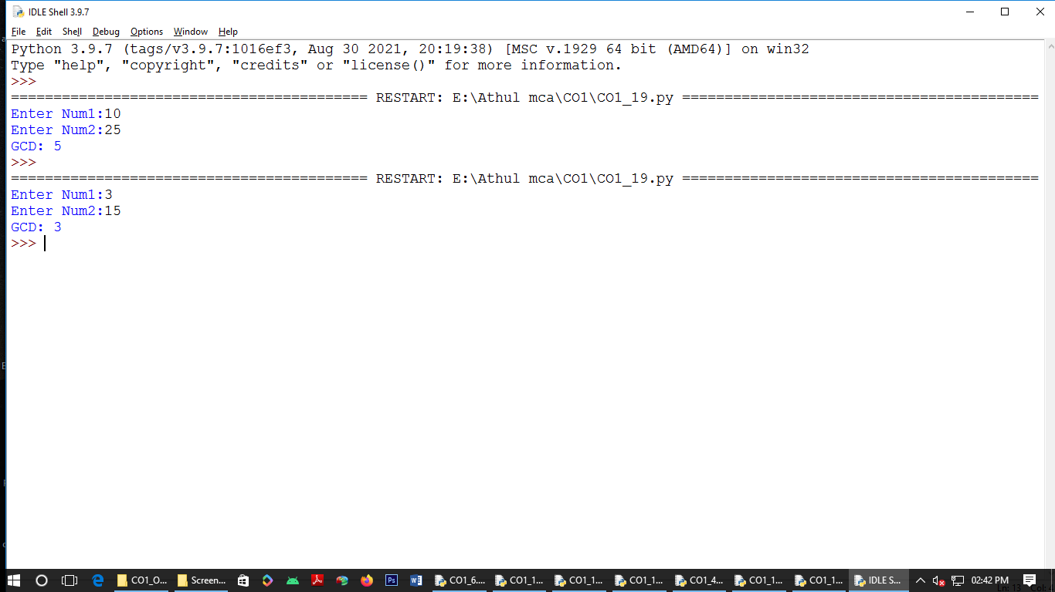

Program 20

num=[7,8,120,25,20,44]

print("Original list",num)

num=[x for x in num if x%2!=0]

print("list after removing:",num)

Output:

